**MOTHERBOARD**

A motherboard (also called mainboard, main circuit board, or mobo) is the main [printed circuit board](https://en.wikipedia.org/wiki/Printed_circuit_board) (PCB) in general-purpose computers and other expandable systems. It holds and allows communication between many of the crucial electronic components of a system, such as the [central processing unit](https://en.wikipedia.org/wiki/Central_processing_unit) (CPU) and [memory](https://en.wikipedia.org/wiki/Computer_memory), and provides connectors for other [peripherals](https://en.wikipedia.org/wiki/Peripherals). Unlike a [backplane](https://en.wikipedia.org/wiki/Backplane), a motherboard usually contains significant sub-systems, such as the central processor, the [chipset](https://en.wikipedia.org/wiki/Chipset)'s [input/output](https://en.wikipedia.org/wiki/Input/output) and memory controllers, [interface](https://en.wikipedia.org/wiki/Interface_(computing)) connectors, and other components integrated for general use.

Motherboard means specifically a PCB with expansion capabilities. As the name suggests, this board is often referred to as the "mother" of all components attached to it, which often include peripherals, interface cards, and [daughterboards](https://en.wikipedia.org/wiki/Expansion_card" \l "Daughterboard" \o "Expansion card): [sound cards](https://en.wikipedia.org/wiki/Sound_card), [video cards](https://en.wikipedia.org/wiki/Video_card), [network cards](https://en.wikipedia.org/wiki/Network_card), [host bus adapters](https://en.wikipedia.org/wiki/Host_bus_adapter), [TV tuner cards](https://en.wikipedia.org/wiki/TV_tuner_card), [IEEE 1394](https://en.wikipedia.org/wiki/IEEE_1394) cards; and a variety of other custom components.

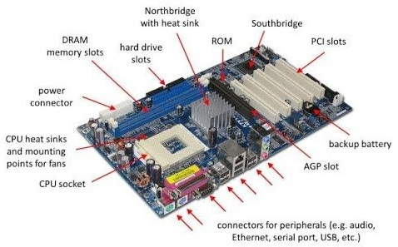

**RAM modules**

In [computing](https://en.wikipedia.org/wiki/Computing), a memory module or RAM ([random-access memory](https://en.wikipedia.org/wiki/Random-access_memory)) stick is a [printed circuit board](https://en.wikipedia.org/wiki/Printed_circuit_board) on which [memory](https://en.wikipedia.org/wiki/Computer_memory) [integrated circuits](https://en.wikipedia.org/wiki/Integrated_circuit) are mounted. Memory modules permit easy installation and replacement in electronic systems, especially computers such as [personal computers](https://en.wikipedia.org/wiki/Personal_computer), [workstations](https://en.wikipedia.org/wiki/Workstation), and [servers](https://en.wikipedia.org/wiki/Server_(computing)). The first memory modules were proprietary designs that were specific to a model of computer from a specific manufacturer. Later, memory modules were standardized by organizations such as [JEDEC](https://en.wikipedia.org/wiki/JEDEC) and could be used in any system designed to use them.

Types of memory module include:

* [TransFlash Memory Module](https://en.wikipedia.org/wiki/TransFlash_Memory_Module)
* [SIMM](https://en.wikipedia.org/wiki/SIMM), a single in-line memory module
* [DIMM](https://en.wikipedia.org/wiki/DIMM), dual in-line memory module
  + [Rambus](https://en.wikipedia.org/wiki/Rambus) memory modules are a subset of DIMMs, but are normally referred to as RIMMs
  + [SO-DIMM](https://en.wikipedia.org/wiki/SO-DIMM), small outline DIMM, a smaller version of the DIMM, used in laptops

Distinguishing characteristics of computer memory modules include voltage, capacity, speed (i.e., [bit rate](https://en.wikipedia.org/wiki/Bit_rate)), and [form factor](https://en.wikipedia.org/wiki/Computer_form_factor). For economic reasons, the large (main) memories found in personal computers, workstations, and non-handheld game-consoles (such as PlayStation and Xbox) normally consist of dynamic RAM (DRAM). Other parts of the computer, such as [cache memories](https://en.wikipedia.org/wiki/Cache_memory) normally use [static RAM](https://en.wikipedia.org/wiki/Static_RAM) ([SRAM](https://en.wikipedia.org/wiki/Static_random_access_memory)). Small amounts of SRAM are sometimes used in the same package as DRAM.[[2]](https://en.wikipedia.org/wiki/Memory_module#cite_note-2) However, since SRAM has high leakage power and low density, [die-stacked](https://en.wikipedia.org/wiki/Three-dimensional_integrated_circuit) DRAM has recently been used for designing multi-megabyte sized processor caches.

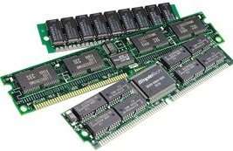

**DAUGHTER BOARD**

The daughter board is a computer hardware. It is also known as the piggyback board, riser card, daughter board, daughtercard or daughter card. A daughter board is a printed circuit board which is connected to the motherboard or expansion card. As compared to the motherboard, it is smaller in size. A daughter board does not act as an expansion card. An expansion card adds extra new functions to the computer. But a daughter board that is connected to the motherboard adds or supports the main functions of the motherboard.

Daughter boards are directly connected to the motherboards. You know that expansion cards are connected to the motherboard by using the bus and other serial interfaces.  But daughter board is directly connected to the board by soldering. As an update of the motherboard or expansion card, daughter boards are released to extend the features and services of the motherboard or expansion cards.

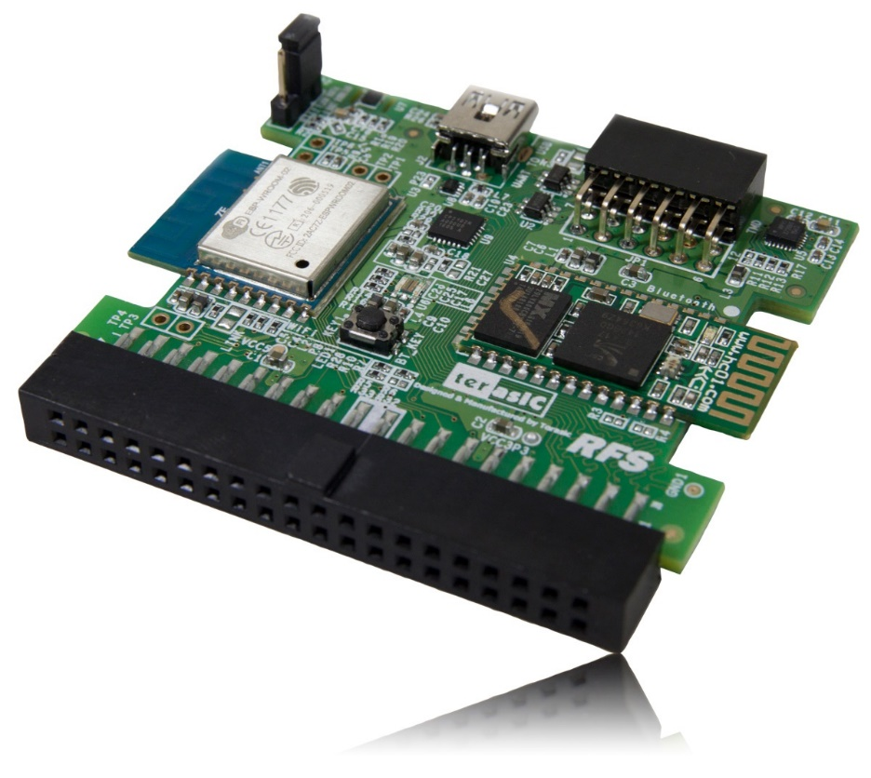

**BUS SLOTS**

Alternatively known as a bus slot or expansion port, an expansion slot is a connection or port inside a [computer](https://www.computerhope.com/jargon/c/computer.htm) on the [motherboard](https://www.computerhope.com/jargon/m/mothboar.htm) or [riser card](https://www.computerhope.com/jargon/r/risecard.htm). It provides an installation point for a hardware expansion card to be connected, which provides additional features to a computer such as video, sound, advanced graphics, Ethernet or memory.

The expansion card has an edge connector that fits precisely into the expansion slot as well as a row of contacts that is designed to establish an electrical connection between the motherboard and the electronics on the card, which are mostly integrated circuits. Depending on the form factor of the case and motherboard, a computer system generally can have anywhere from one to seven expansion slots. With a backplane system, up to 19 expansion cards can be installed.

Expansion cards can provide various functions including:

* Sound
* Modems
* Network
* Interface adapters
* TV and radio tuning
* Video processing
* Host adapting such as redundant array of independent disks or small computer system interface

* Solid-state drive
* Power-on self-test
* Advanced multirate codec
* Basic input/output system (BIOS)
* Expansion read-only memory (ROM)
* Security devices
* RAM memory

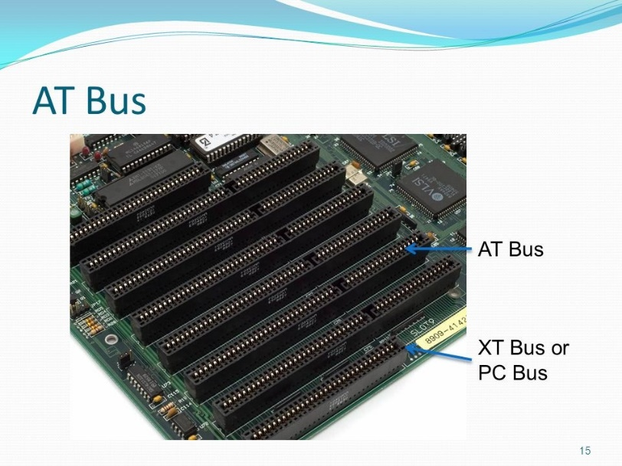

**SMPS**

A switched-mode power supply (SMPS) is an electronic circuit that converts power using switching devices that are turned on and off at high frequencies, and storage components such as inductors or capacitors to supply power when the switching device is in its non-conduction state.

Switching power supplies have high efficiency and are widely used in a variety of electronic equipment, including computers and other sensitive equipment requiring stable and efficient power supply.

A switched-mode power supply is also known as a switch-mode power supply or switching-mode power supply.

Switched-mode power supplies are classified according to the type of input and output voltages. The four major categories are:

* AC to DC
* DC to DC
* DC to AC
* AC to AC

A basic isolated AC to DC switched-mode power supply consists of:

* Input rectifier and filter
* Inverter consisting of switching devices such as MOSFETs
* Transformer
* Output rectifier and filter
* Feedback and control circuit

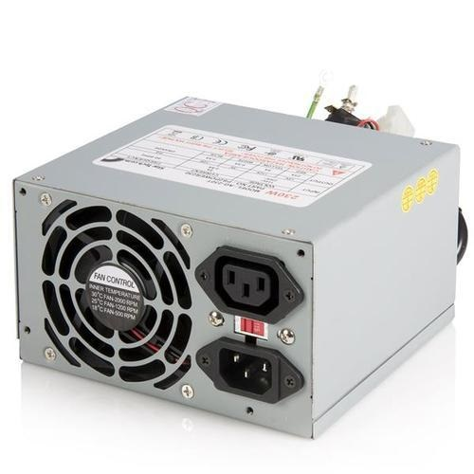 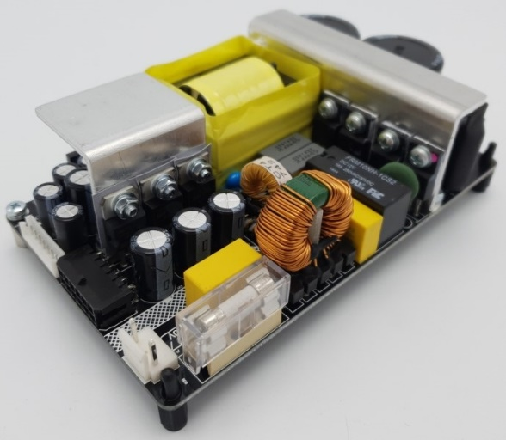

**INTERNAL STORAGE DEVICES**

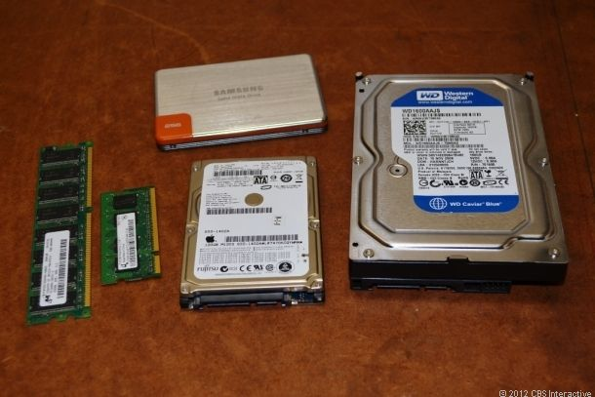

A storage unit is a part of the computer system which is employed to store the information and instructions to be processed. A storage device is an integral part of the computer hardware which stores information/data to process the result of any computational work. Without a storage device, a computer would not be able to run or even boot up. Or in other words, we can say that a storage device is hardware that is used for storing, porting, or extracting data files. It can also store information/data both temporarily and permanently. Computer storage is of two types:

* **Primary Storage Devices:** It is also known as internal memory and main memory. This is a section of the CPU that holds program instructions, input data, and intermediate results. It is generally smaller in size. RAM (Random Access Memory) and ROM (Read Only Memory) are examples of primary storage.
* **Secondary Storage Devices:**Secondary storage is a memory that is stored external to the computer.  It is mainly used for the permanent and long-term storage of programs and data. Hard Disk, CD, DVD, Pen/Flash drive, SSD, etc, are examples of secondary storage.

**INTERFACING PORTS**

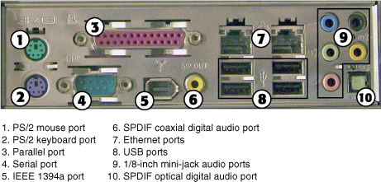

A **port** is basically a physical docking point which is basically used to connect the external devices to the computer, or we can say that A port act as an interface between the computer and the external devices, e.g., we can connect hard drives, printers to the computer with the help of ports.

**Characteristics of Ports**

A port has the following characteristics −

* External devices are connected to a computer using cables and ports.
* Ports are slots on the motherboard into which a cable of external device is plugged in.
* Examples of external devices attached via ports are the mouse, keyboard, monitor, microphone, speakers, etc.